**Design Patterns and Principles**

**Exercise 1: Implementing the Singleton Pattern**

**Scenario:**

You need to ensure that a logging utility class in your application has only one instance throughout the application lifecycle to ensure consistent logging.

**Steps:**

1. **Create a New Java Project:**
   * Create a new Java project named **SingletonPatternExample**.
2. **Define a Singleton Class:**
   * Create a class named Logger that has a private static instance of itself.
   * Ensure the constructor of Logger is private.
   * Provide a public static method to get the instance of the Logger class.
3. **Implement the Singleton Pattern:**
   * Write code to ensure that the Logger class follows the Singleton design pattern.
4. **Test the Singleton Implementation:**
   * Create a test class to verify that only one instance of Logger is created and used across the application.

**Implementation:**

**

**Exercise 2: Implementing the Factory Method Pattern**

**Scenario:**

You are developing a document management system that needs to create different types of documents (e.g., Word, PDF, Excel). Use the Factory Method Pattern to achieve this.

**Steps:**

1. **Create a New Java Project:**
   * Create a new Java project named **FactoryMethodPatternExample**.
2. **Define Document Classes:**
   * Create interfaces or abstract classes for different document types such as **WordDocument**, **PdfDocument**, and **ExcelDocument**.
3. **Create Concrete Document Classes:**
   * Implement concrete classes for each document type that implements or extends the above interfaces or abstract classes.
4. **Implement the Factory Method:**
   * Create an abstract class **DocumentFactory** with a method **createDocument()**.
   * Create concrete factory classes for each document type that extends DocumentFactory and implements the **createDocument()** method.
5. **Test the Factory Method Implementation:**
   * Create a test class to demonstrate the creation of different document types using the factory method.

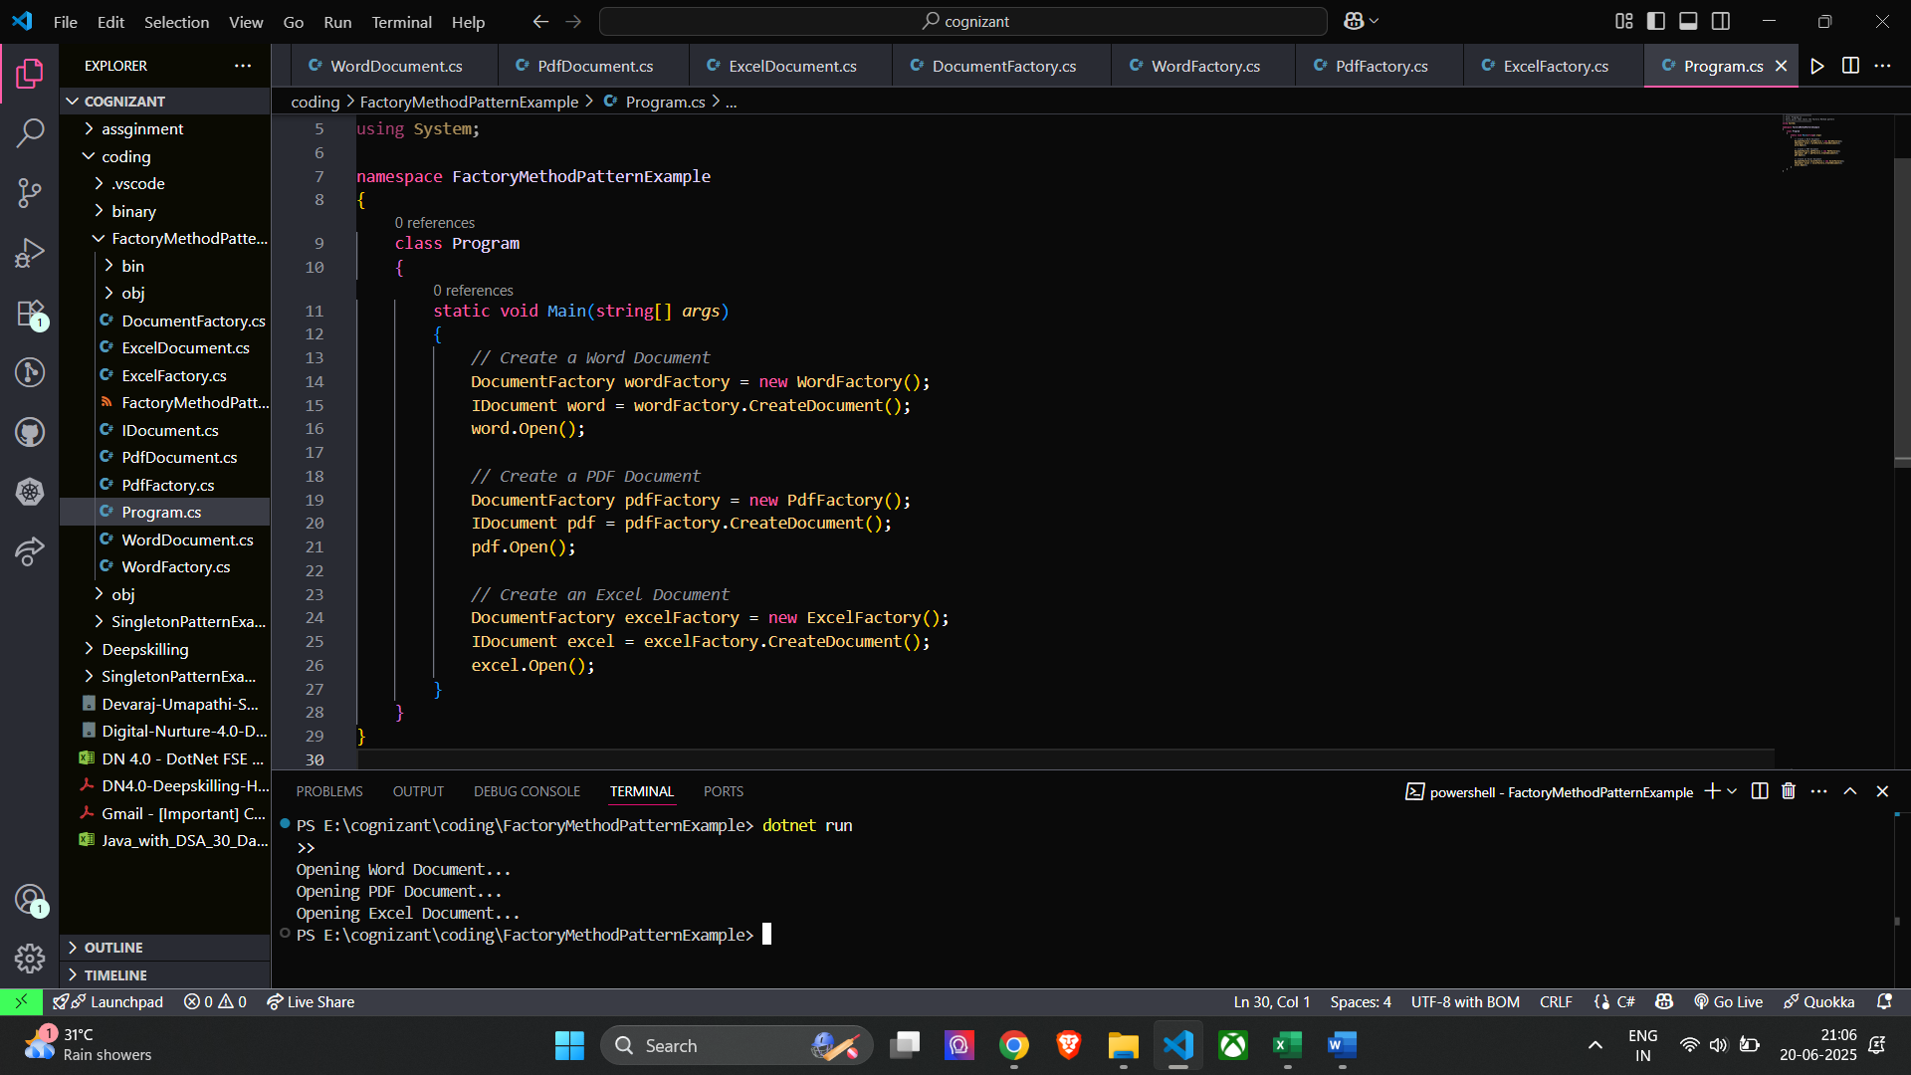**Implementation:**

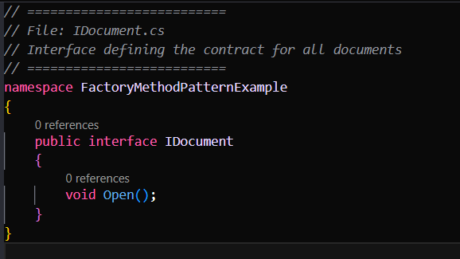

**Algorithms Data Structures**

**Exercise 2: E-commerce Platform Search Function**

**Scenario:**

**You are working on the search functionality of an e-commerce platform. The search needs to be optimized for fast performance.**

**Steps:**

1. **Understand Asymptotic Notation:**
   * **Explain Big O notation and how it helps in analyzing algorithms.**
   * **Describe the best, average, and worst-case scenarios for search operations.**
2. **Setup:**
   * **Create a class Product with attributes for searching, such as productId, productName, and category.**
3. **Implementation:**
   * **Implement linear search and binary search algorithms.**
   * **Store products in an array for linear search and a sorted array for binary search.**
4. **Analysis:**
   * **Compare the time complexity of linear and binary search algorithms.**
   * **Discuss which algorithm is more suitable for your platform and why**

**Implementation:**

**Time Complexity Comparison**

**Linear Search:**

* Best Case: O(1) → Item is found at the beginning.
* Worst Case: O(n) → Item is at the end or not present.
* Performance: Slower for large product lists because it checks each item one by one.

**Binary Search:**

* Best Case: O(1) → Item is found in the middle.
* Worst Case: O(log n) → Efficient even for large data because it cuts the list in half with each step.
* Performance: Much faster for large, sorted data.

In a real-world e-commerce platform, where thousands or even millions of products may exist, Binary Search is the better choice because:

* It is much faster when searching through large amounts of data.
* It reduces the number of comparisons needed by continuously dividing the search range.
* It is ideal when the product list is sorted, like by product ID or price.

On the other hand, Linear Search is:

* Simple and works on unsorted data.
* Useful for very small product lists or when you need to check every product manually (like for keyword matches or filters).

**Implementation** :

**The concept of recursion and how it can simplify certain problems:**

Recursion is a programming technique where a function calls itself to solve a smaller or simpler version of the same problem. It continues until it reaches a base case, which is a condition that stops the recursion.

It makes code simpler and cleaner, especially for problems that follow a repetitive or self-similar pattern (like calculating interest, traversing a tree, solving factorials, etc.).

In financial forecasting, recursion allows us to calculate future values year-by-year, based on the previous year’s result — exactly how compound growth works.

**Time Complexity of Your Recursive Algorithm:**

Time Complexity: O(n)

Because it makes one recursive call for each year until it reaches year 0. So, for 10 years, it performs 10 calls.

Space Complexity: O(n)

**Optimize the Recursive Solution:**

Recursion can become inefficient when it repeats calculations for the same values multiple times especially for large inputs.

Optimization Technique: Memoization

* Store results of each year’s calculation in a dictionary or cache.
* If the function is called again for the same input, return the result directly from memory instead of recalculating.

This reduces unnecessary work and makes the algorithm much faster.

Time Complexity with Memoization:

* O(n) — same as before, but much faster because each result is computed only once.
* Space Complexity: O(n) — for the memoization dictionary.